INSTRUCTIONS FOR SUBMITTING AN OZ PROBLEM REPORTING TICKET

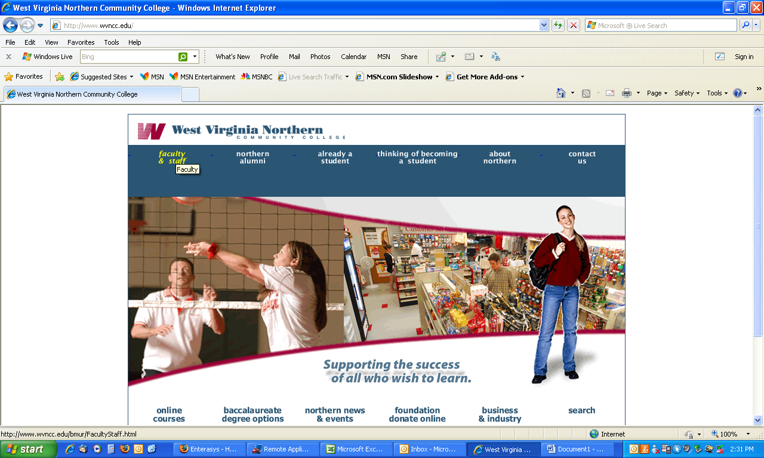

Under the Faculty/Staff page, select CAMPUS INTRANET LINKS and OZ PROBLEM REPORTING LOGIN.

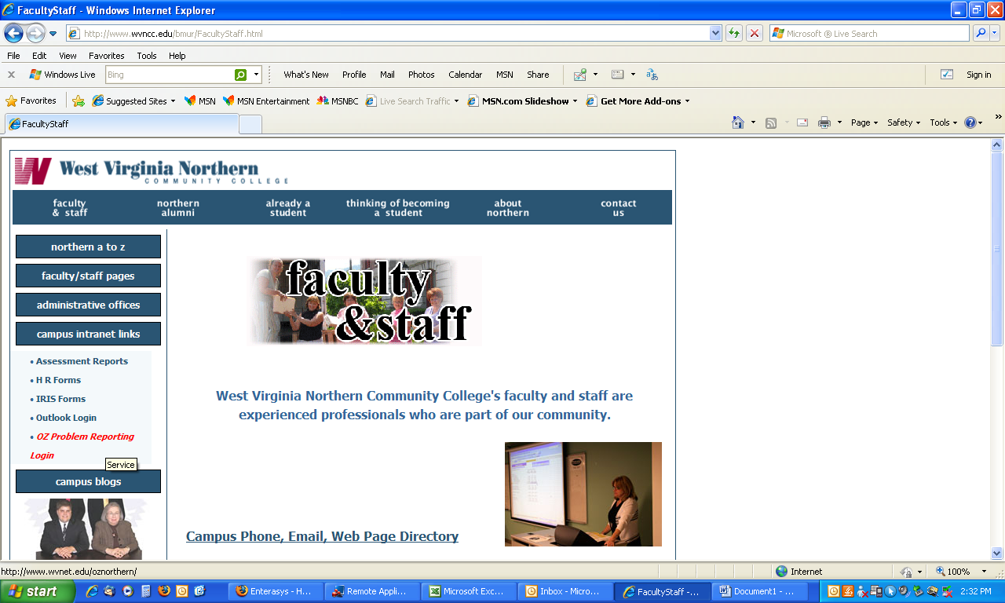

From the log in screen, use the pull down menu to select NORTHERN IT.

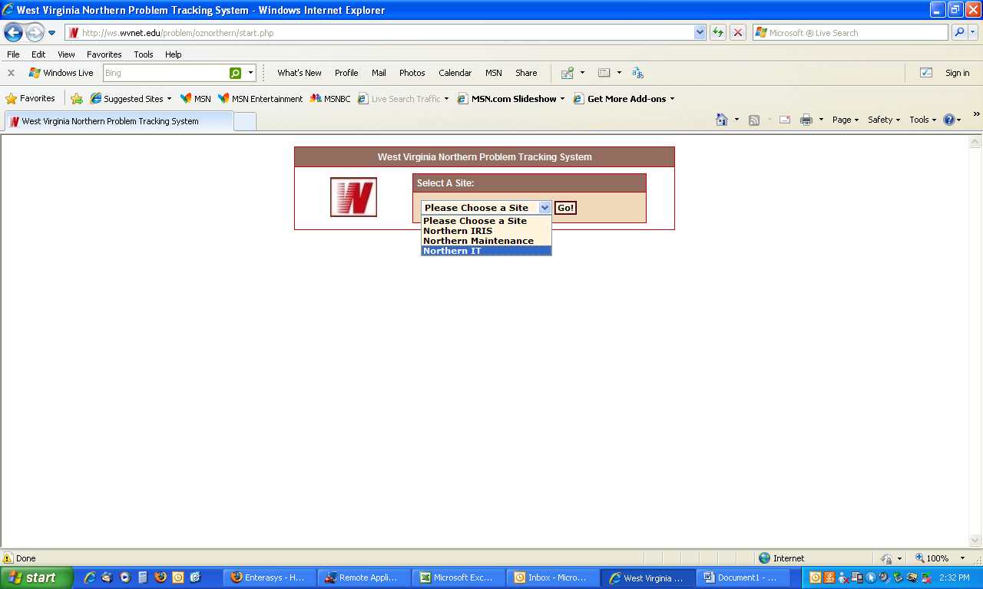

At the log in screen enter your username and password. If you do not already have one, you can register for a username and select your password.

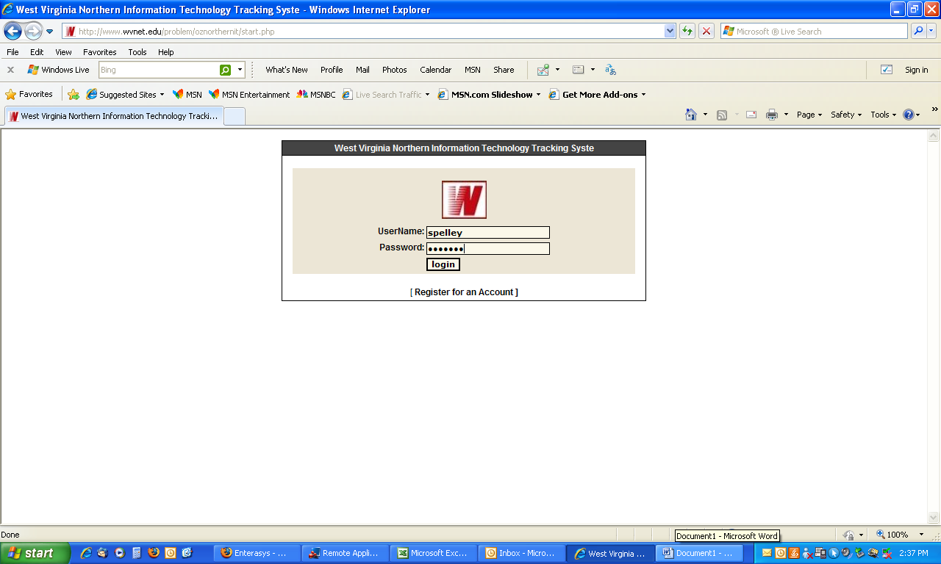

If you have forgotten your password or enter it incorrectly, you can select the link to have your password emailed to you. If you need further assistance, please call 8826 or 8825.

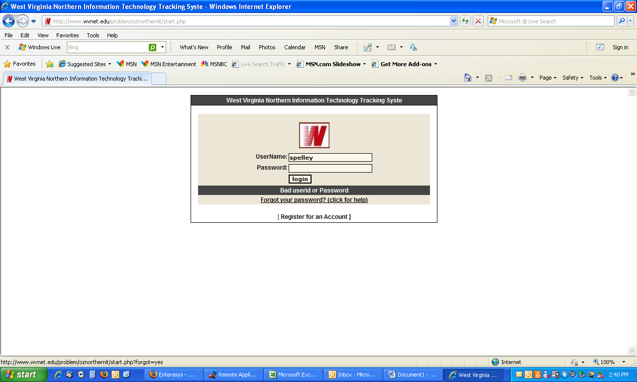

To create a problem ticket, select CREATE TICKET on the left hand side of the screen.

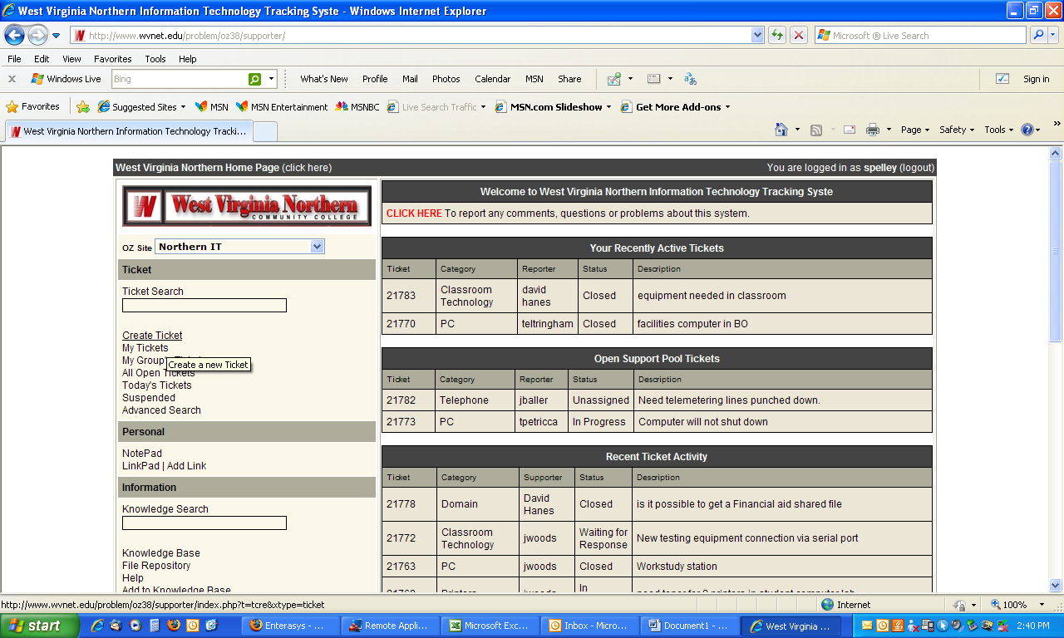

Follow the step by step question and enter the information as best you can, providing a description of the problem and selecting the appropriate category.

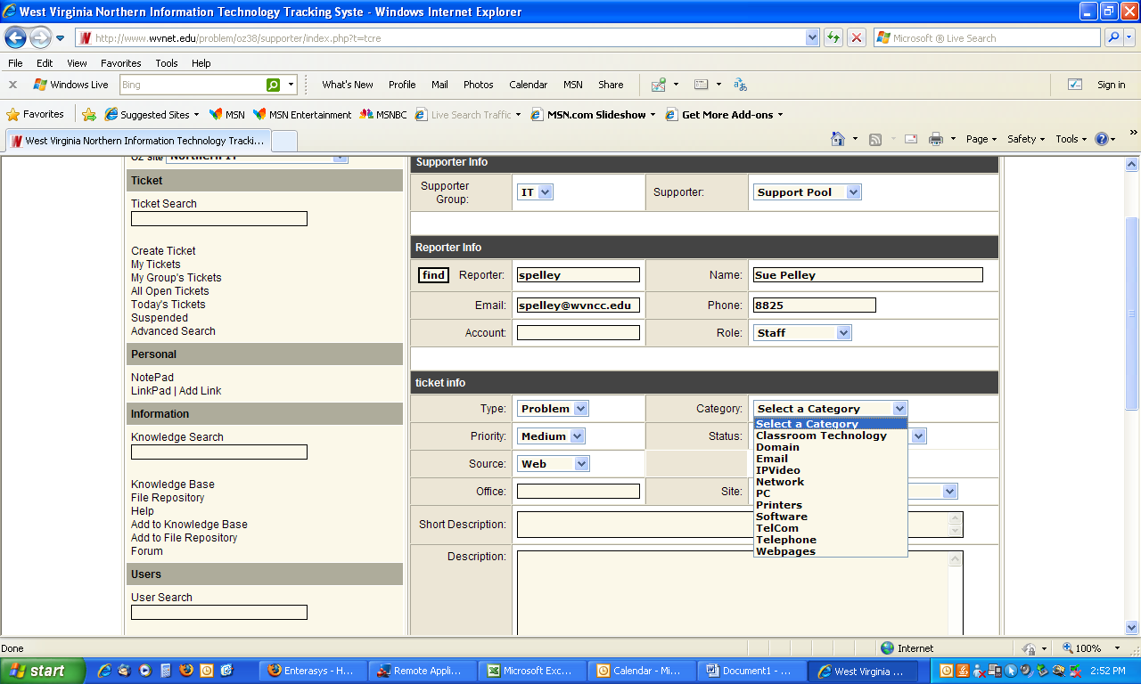

When you are done, click the SUBMIT button at the bottom of the page. You will receive an email at the address you registered with your account every time the ticket is updated or as it is completed.



