**FOR IMMEDIATE RELEASE**

Monday, July 6, 2020

**Contact:**

David Barnhardt

Director of Marketing & PR

Ph – 304-214-8820

[dbarnhardt@wvncc.edu](mailto:dbarnhardt@wvncc.edu)

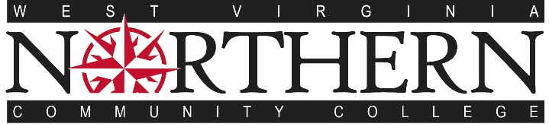

**WVNCC to host four Virtual Open Houses and give away three $1,000 scholarships**

WHEELING, W.VA – West Virginia Northern Community College (WVNCC) will host four Virtual Open Houses via Zoom for perspective students and their families to learn about programs, the admissions process, financial aid, student activities and more. Anyone who attends one of the Virtual Open Houses will be eligible to win one of three $1,000 scholarships to WVNCC for the Fall Semester.

WVNCC Virtual Open Houses will take place on Tuesday, July 28, from 5:30 – 7 p.m., Wednesday, July 29, from noon-1:30 p.m., Thursday, July 30, from 9 – 10:30 a.m. and on Saturday, August 1, from 10 – 11:30 a.m. After a brief overview of the event and WVNCC, participants will be able to move into virtual breakout rooms to gather information and ask questions to faculty and staff.

Anyone interested in attending the event can go to [www.wvncc.edu](http://www.wvncc.edu) and visit the Open House page to get the Zoom link.

Classes for the fall semester begin August 24. During the virtual event perspective students can learn how to apply and register for classes. Applications are available online at [www.wvncc.edu](http://www.wvncc.edu).

West Virginia Northern Community College is a two-year comprehensive community college accredited by the Higher Learning Commission. Founded in 1972, WVNCC offers transfer degrees and programs in the Liberal Arts, Career-Technical and Community and Continuing Education on three campuses including New Martinsville, Weirton and Wheeling.

###

1704 Market St. Wheeling, W.VA P: 304-233-5900 www.wvncc.edu